
+91 7488835231
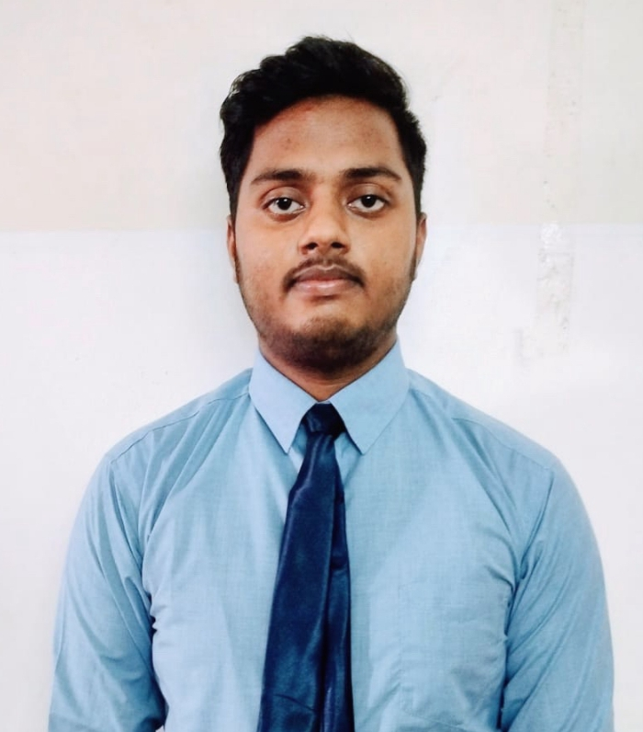
1 77777 66666



PREM AMAN
linkedin.com/in/premaman
amanprem374@gmail.com

Ranchi, Jharkhand

github.com/premaman

SUMMARY

Logical and organised individual with a strong foundation in software engineering. Seeking to raise coding KPIs by providing error-free codes. Ability to translate business requirments into innovative software solutions.
.

TECHNICAL SKILLS

Web Development (FE)

Programming With Python | C,C++ | mySQL | Java

KOTLIN

OS : Windows, Linux, Unix, and MacOS

CERTIFICATIONS

LinkedIn Certificates
AISucceeding in Web Development: FS and FE
Getting started with AI and Machine Learning
STC on Intelligence for the Digital Age
Technocean:
AR/VR/Game Design workshop(Technocean)
Powering AI and Analytics using SAS tools (Technocean)

POWER SKILLS
Sociable and team player

Observant and hands on learner
Adaptable

EXTRA CURRICULAR ACTIVITIES
Inter School Quiz Competition
Inter Zone Kabaddi tournament. Feb 21
PROJECTS
Income Tax Department (Website). Aug’22
Optimize the website for Easy Accessible, Fast, Simple
For Everyone and optimize for all devices.

Paper Piano (Electronic Project). Apr’23
The Piano Is tuned by Software to produce different
sounds at different frequencies.

Medicine Record Management System(C program). Apr’23
This program is a simple patient record management
system. It allows the user to add new patient records,
view all existing patient records, search for a specific
patient record, and delete a specific patient record.

Designing using Autocad. May’23
Gain proficiency in creating technical drawings, 2D and
3D models, and understanding the application of CAD
software in design.

ACHIEVEMENTS

2 Star Rating in Python on HackerRank
3 Star Rating in C on HackerRank

EDUCATION

B.Tech. in Computer Science and Engineering Aug '22 - Present Lovely Professional University |Phagwara, IN
CGPA 8

Higher Secondary Apr '21 - Mar '22
M.B.DAV Public School|JHARKHAND, IN
Percentage: 82.0%

LANGUAGES

English
Hindi

